### ABSTRACT

In today's fast-paced world, finding reliable and skilled workers such as painters, carpenters, and plumbers can be a challenging task. The traditional methods of hiring through word-of-mouth or local advertisements often fall short in terms of efficiency and reliability. To address this gap, we propose the development of an online portal exclusively dedicated to hiring skilled workers. This platform aims to streamline the process, making it easier for individuals and businesses to find and hire qualified professionals for their tasks.

Additionally, it will help workers find job opportunities, enhancing their ability to connect with potential clients and grow their businesses this portal will keep workers informed about new opportunities, enabling them to apply promptly and efficiently, thus fostering a more effective and reliable hiring process in today's dynamic market.

CHAPTER 1

**INTRODUCTION**

* 1. **INTRODUCTION**

Finding reliable and skilled workers such as painters, carpenters, and plumbers can be a challenging task. Traditional methods of hiring through word-of-mouth or local advertisements often fall short in terms of efficiency and reliability. These outdated approaches can be time-consuming and frequently fail to connect individuals and businesses with the best available talent. This inefficiency underscores the need for a more streamlined and effective solution.

To address this gap, we propose the development of an online portal exclusively dedicated to hiring skilled workers. This platform aims to revolutionize the hiring process by making it easier for individuals and businesses to find and hire qualified professionals for their tasks. By leveraging advanced search filters, user-friendly interfaces, and robust verification systems, the portal will ensure a quick and reliable way to connect with skilled workers.

Moreover, this platform will significantly benefit workers by providing them with ample job opportunities. The portal will enhance their ability to connect with potential clients and grow their businesses. Job alerts and notifications will keep workers informed about new opportunities, enabling them to apply promptly and efficiently. This will foster a more effective and reliable hiring process in today's dynamic market, benefiting both clients and skilled workers alike.

### 1.2 PROBLEM STATEMENT

The traditional methods of hiring skilled workers such as painters, carpenters, and plumbers are increasingly inadequate in meeting the needs of individuals and businesses. Reliance on word-of-mouth and local advertisements often results in inefficiencies and unreliable outcomes, failing to connect clients with the best available talent. These outdated approaches can be time-consuming and frustrating, leading to delays and suboptimal results for both clients and workers. There is a pressing need for a more streamlined, efficient, and reliable solution to bridge the gap between demand and supply in the skilled labor market.

To address this challenge, we propose the development of an online portal exclusively dedicated to hiring skilled workers. This platform will leverage advanced search filters, user-friendly interfaces, and robust verification systems to connect individuals and businesses with qualified professionals quickly and reliably. Additionally, it will provide workers with ample job opportunities and timely notifications, enhancing their ability to find work and grow their businesses. This solution aims to transform the hiring process, fostering a more effective and reliable market for skilled labor.

* 1. **PROJECT SCOPE AND PROJECT RELEVANCE**

The project addresses a significant gap in the traditional methods of hiring skilled workers. By providing a centralized online platform, it offers the following benefits:

* Efficiency: Streamlines the hiring process for both clients and workers, saving time and effort.
* Reliability: Ensures the quality of service by hiring good workers and providing customer support.
* Accessibility: Broadens the pool of potential workers and clients beyond geographical limitations.
* Economic Growth: Stimulates job creation and economic activity by connecting skilled workers with in-demand opportunities.
* Improved Customer Satisfaction: Delivers a more convenient and satisfying experience for clients seeking skilled labor.

The project has the potential to revolutionize the skilled labor market by creating a more efficient, transparent, and reliable platform that benefits both clients and workers.

**1.4 OBJECTIVES OF THE PROPOSED SYSTEM**

The primary objectives of the proposed online portal are:

**For Users**

* **Efficient worker discovery:** To provide a platform for quick and easy identification of skilled workers for various tasks.
* **Reliable workforce access:** To ensure a consistent supply of qualified professionals, reducing downtime and project delays.
* **Cost-effective hiring:** To streamline the hiring process, reducing recruitment costs and time.

**For Skilled Workers**

* **Increased job opportunities:** To provide a wider reach for skilled workers to find potential clients and projects.
* **Improved income potential:** To enable workers to increase their earnings by connecting with more clients.
* **Efficient job search:** To streamline the job search process by providing a centralized platform to find and apply for jobs.
* **Business growth:** To help skilled workers build their reputation and grow their businesses through client reviews and ratings.

CHAPTER 2

**SYSTEM ANALYSIS**

### 2.1 INTRODUCTION

Finding reliable and skilled workers such as painters, carpenters, and plumbers has become increasingly challenging. Traditional hiring methods, like word-of-mouth referrals and local advertisements, often lack efficiency and reliability, making it difficult for individuals and businesses to connect with the best talent available. These outdated approaches are time-consuming and frequently fall short in matching the right workers to the right jobs, highlighting the need for a more effective solution.

To bridge this gap, we propose the creation of an online portal dedicated exclusively to hiring skilled workers. This innovative platform aims to transform the hiring process by providing a seamless and efficient way for individuals and businesses to find and hire qualified professionals. Utilizing advanced search filters, intuitive interfaces, and comprehensive verification systems, the portal will facilitate quick and dependable connections between clients and skilled workers.

* 1. **EXISTING SYSTEM**

The current system for finding and hiring skilled workers such as painters, carpenters, and plumbers primarily relies on:

1. **Word-of-Mouth Referrals**: Personal recommendations from friends, family, or colleagues.
2. **Local Advertisements**: Notices in community bulletin boards, local newspapers, and flyers.
3. **Community Networks**: Informal networks within local communities or professional circles.
   * 1. **Limitations of Existing System**

* **Inefficiency**: The process is time-consuming and often requires extensive networking and repeated follow-ups.
* **Limited Reach**: Traditional methods have a limited geographical reach, making it difficult to connect with a broader audience or the best available talent.
* **Fragmented Information**: Information about available workers and job opportunities is scattered and not centralized, making it hard to access and compare options.
* **Inconsistent Availability**: Workers and employers may struggle to find each other at the right time, leading to missed opportunities and delays.
  1. **PROPOSED SYSTEM**

We propose developing an online portal exclusively dedicated to hiring skilled workers. The proposed system will offer the following features:

1. **Centralized Platform**: A single, centralized platform where individuals and businesses can find and hire skilled workers quickly and efficiently.
2. **User-Friendly Interface**: An intuitive and easy-to-navigate interface that simplifies the hiring process for both employers and workers.
3. **Real-Time Availability**: Real-time updates on workers' availability and job opportunities.
4. **Support and Assistance**: Customer support and assistance features to help users navigate the platform and address any issues.
   * 1. **Advantages of Proposed System**

* I**ncreased Efficiency**: Streamlines the hiring process, saving time and effort for both employers and workers.
* **Broader Reach**: Expands the geographical reach, connecting a wider audience with skilled workers and job opportunities.
* **Centralized Information**: Provides a single source of truth for available workers and job opportunities, making it easy to access and compare options.
* **Improved Communication**: Facilitates clear and direct interactions between employers and workers.

**2.4 FEASIBILITY STUDY**

The main objective of the feasibility study is to take care of the technical, Operational, logical, and economic feasibility of developing the computerized system. All systems are feasible, given unlimited resources and infinite time. It is both necessary and useful to evaluate the feasibility of the project at System study phase itself. The feasibility study to be conducted for this project involves:

➢ Technical Feasibility

➢ Operational Feasibility

➢ Economic Feasibility

➢ Logical Feasibility

**2.4.1 Technical Feasibility**

Technical feasibility includes Risk Resources availability and technologies. The management provides latest hardware and software facilities for the successful completion of the projects. With these latest hardware and software support the system will perform extremely well.

**2.4.2 Operational Feasibility**

In the existing manual system, it is very difficult to maintain and update huge amount of information. The development of the system was started because of the requirement put forward by the management of the concerned entity. This system will handle the request in a better way and make the process easier thus, it is sure that the system developed is operationally feasible.

**2.4.3 Economic Feasibility**

In the economic feasibility the development cost of the system is evaluated weighing it against the ultimate benefit derived from the new system. It is found that the benefit, from the new system would be more than the cost and time involved in its development

**2.4.4 Legal Feasibility**

In the legal feasibility it is necessary to check that the software we are going to develop is legally correct which means that the ideas which we have taken for the proposed system will be legally implemented or not. So, it is also a major step in feasibility study.

* 1. **SOFTWARE ENGINEERING PARADIGM APPLIED**

The systems development life cycle (SDLC), also referred to as the application development lifecycle, is a term used in systems engineering, information systems and software engineering to describe a process for planning, creating, testing, and deploying an information system. The systems development life-cycle concept applies to a range of hardware and software configurations, as a system can be composed of hardware only, software only, or a combination of both. A systems development life cycle is composed of several clearly defined and distinct work phases which are used by systems engineers and systems developers to plan for, design, build, test, and deliver information systems. Like anything that is manufactured on an assembly line, an SDLC aims to produce high-quality systems that meet or exceed customer expectations, based on customer requirements, by delivering systems which move through each clearly defined phase, within scheduled time frames and cost estimates. Computer systems are complex and often (especially with the recent rise of service-oriented architecture) link multiple traditional systems potentially supplied by different software vendors. To manage this level of complexity, a number of SDLC models or methodologies have been created, such as "waterfall"; "spiral"; "Agile software development"; "rapid prototyping"; "incremental"; and "synchronize and stabilize".

The SDLC adheres to important phases that are essential for developers, such as planning, analysis, design,and implementation.It includes evaluation of present system, information gathering, and feasibility study and request approval. A number of SDLC models have been created: waterfall, fountain, spiral, build and fix, rapid prototyping, incremental, synchronize and stabilize. The oldest of these, and the best known, is the waterfall model: a sequence of stages in which the output of each stage becomes the input for the next.This Project uses Incremental Process Model.

CHAPTER 3

**SYSTEM ENVIRONMENT**

### 3.1 INTRODUCTION

Environment refers to the collection of hardware and software tools a system developer uses to build software systems. As technology improves and user expectations grow, an environment's functionality tends to change. Over the last 20 years the set of software tools available to developers has expanded considerably. The evolution of environments also demands that we distinguish basic operating system facilities fundamental services such as memory, data, and multiple program management—from the enhanced functionality that characterizes state-of-the-art environments. This enhanced functionality is typically achieved through tools such as browsers, window managers, configuration managers, and task managers. In a sense, environments have evolved in concert with the software engineering community's understanding of the tasks involved in the development of software systems.

### 3.2 SOFTWARE REQUIREMENTS SPECIFICATION

One of the most difficult tasks is that, the selection of the software, once the system requirement known is determining whether particular software fits the requirements. After initial selection further security is needed to determine the desirability of particular software with other candidates. This section first summarizes the application requirement question and then suggests more detailed comparisons.

These are the software configurations used

* Operating system: Windows 11

* Platform: VS Code

* Front end: HTML, CSS, JavaScript,Bootstrap 5

* Back end: Django

* Database: SQLite

### 3.3 HARDWARE REQUIREMENTS SPECIFICATION

### The selection of Hardware is very important in the existence and proper working of any software. In the selection of hardware there are many features that influence the success of a project.

These are the Hardware interfaces used

* Processor: Intel Core i5 or higher

* RAM: Approximately 2GB

* Hard Disk: Approximately 2GB

### 3.4 TOOLS, PLATFORMS

**FRONT END TOOL**

**1. HTML (Hypertext Markup Language)**

HTML is the standard markup language used for creating web pages. It structures the content on the web by defining elements such as headings, paragraphs, lists, links, images, and more. HTML provides the basic building blocks of a website, allowing developers to organize content in a hierarchical manner. It is essential for laying the foundation of any web application, enabling browsers to render and display text, media, and other elements in a structured way.

**2. CSS (Cascading Style Sheets)**

CSS is a stylesheet language used to control the presentation of HTML elements on a web page. It allows developers to define the look and feel of a website, including layout, colors, fonts, and spacing. CSS enables the separation of content (HTML) from design, making it easier to maintain and update the visual aspects of a website. By using CSS, developers can create responsive designs that adapt to different screen sizes and devices, enhancing user experience.

**3. Bootstrap 5**

Bootstrap 5 is a popular front-end framework that simplifies the development of responsive and mobile-first websites. It provides a collection of pre-designed components, such as navigation bars, buttons, forms, and modals, along with a grid system for creating layouts. Bootstrap 5 is built with HTML, CSS, and JavaScript, making it easy to integrate with existing projects. With its built-in utility classes and customizable themes, Bootstrap allows developers to create professional-looking websites quickly and efficiently.

**4. JavaScript**

JavaScript is a versatile programming language used to add interactivity and dynamic content to web pages. It runs directly in the browser, enabling developers to create features such as form validation, animations, and real-time updates without needing to reload the page. JavaScript is essential for creating modern, interactive web applications, allowing developers to manipulate HTML and CSS, respond to user events, and interact with APIs. It also supports frameworks and libraries like React, Angular, and Vue.js, which are used to build complex web applications

**BACK END TOOL**

**1. Django**

Django is a high-level Python web framework that promotes rapid development and clean, pragmatic design. It is designed to help developers build robust and scalable web applications quickly by providing a comprehensive suite of features, including an ORM (Object-Relational Mapping) system, an admin interface, and powerful security features. Django follows the "batteries-included" philosophy, offering built-in functionalities like authentication, URL routing, and form handling, which allows developers to focus on writing application-specific code. Django is well-suited for developing complex, data-driven websites and applications with minimal effort.

**2. SQLite**

SQLite is a lightweight, self-contained, serverless database engine that is widely used in web applications, mobile apps, and embedded systems. Unlike traditional database management systems, SQLite does not require a separate server process and stores the entire database in a single file on disk, making it easy to deploy and manage. Despite its simplicity, SQLite supports most of the SQL standards and is capable of handling small to medium-sized applications with ease. It is an excellent choice for projects that need a reliable, zero-configuration database solution.

CHAPTER 4

**SYSTEM DESIGN**

**4.1 INTRODUCTION**

Design is the first step in the development phase for any techniques and principles for the purpose of defining a device, a process or system in sufficient detail to permit its physical realization. Once the software requirements have been analyzed and specified the software design involves three technical activities - design, coding, implementation and testing that are required to build and verify the software. The design activities are of main importance in this phase, because in this activity, decisions ultimately affecting the success of the software implementation and its ease of maintenance are made. These decisions have the final bearing upon reliability and maintainability of the system. Design is the only way to accurately translate the customer’s requirements into finished software or a system. Design is the place where quality is fostered in development. Software design is a process through which requirements are translated into a representation of software. Software design is conducted in two steps. Preliminary design is concerned with the transformation of requirements into data.

**4.2 DATAFLOW DIAGRAM**

The data flow diagram is also known as “bubble chart” has the purpose of clarifying system requirements and identifying major transformations that will become programs in system design so it is the starting point of specification down to the lowest level of detail. A DFD consists of a series of bubbles joined by lines. The bubbles represent data transformation and the lines represent the data flow in the system.

DFD Symbols:

* A system defined a source or destination of data.
* An arrow identifies data flow, data in motion.
* A circle represents the process that transforms incoming data flow to outgoing data flow.
* An open rectangular is data store-data at rest or a temporary repository of data.

Arrow identifies Data Flow – Data in motion. It is a pipeline through which information flows. Data flow is a route, which enables packets travels from one point to another. Data may flow from a source to a processor and from data store or process. An arrow line depicts the flow, with arrow head pointing in the direction of the flow.

A process represents a transformation where incoming data flows are changed into outgoing data flows.

A data store is a respiratory of data that is to be stored for use by one or more process may be as simple as buffer or queue or sophisticated as relational database. They should have clear names. If a process merely uses the content of store and does not alter it, the overhead goes from the store to the process.

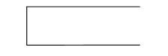

A square defines a Source or Destination of system data. A source or sink is a person or part of an organization which enters or receives information from the system but is considered to be the contest of data flow model.

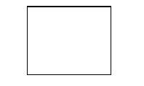

LEVEL 0

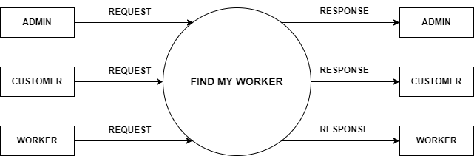

CUSTOMER LEVEL 1

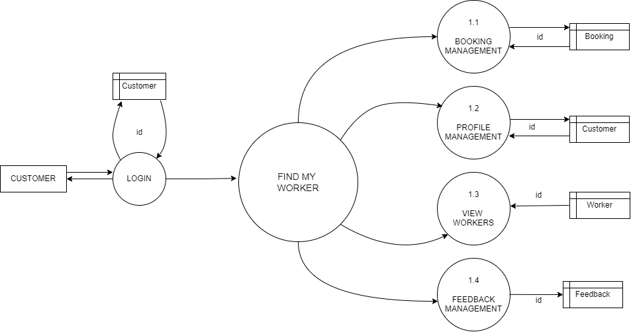

WORKER LEVEL 1

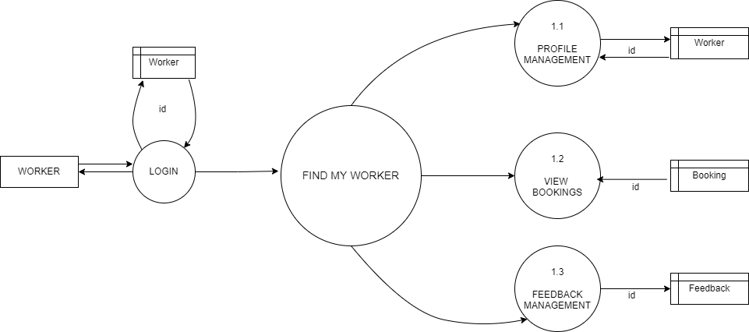

ADMIN LEVEL 1

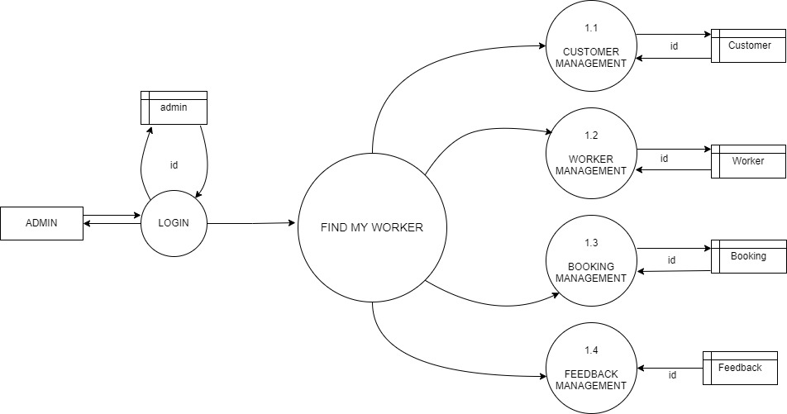

ADMIN LEVEL 1.1

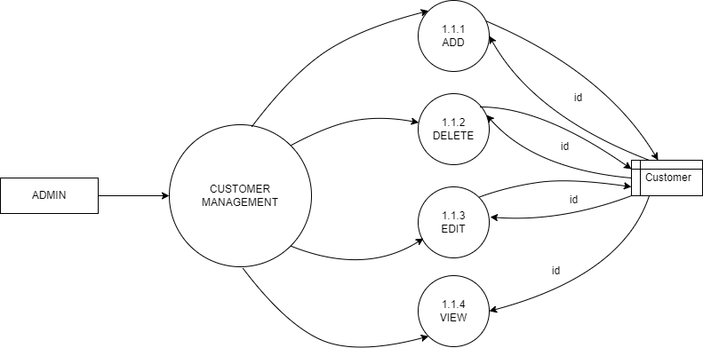

ADMIN LEVEL 1.2

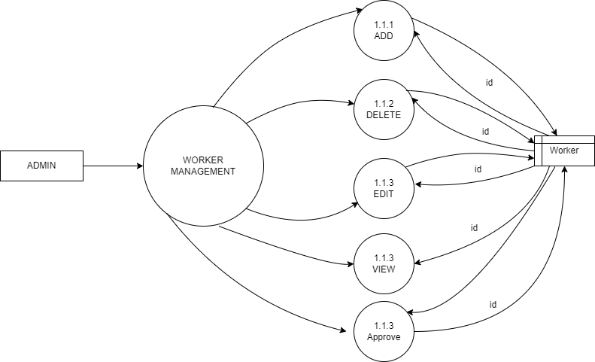

ADMIN LEVEL 1.3

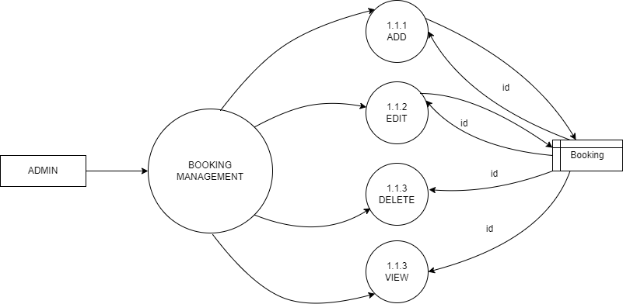

ADMIN LEVEL 1.4

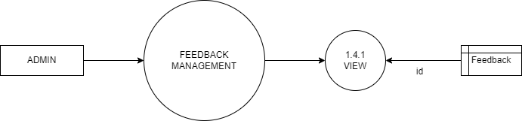

**4.4 ER DIAGRAM**

Entity-Relationship Diagram (ERD) is a graphical representation used in database design to illustrate the logical structure of a database system. It visually depicts the entities (objects), attributes (properties), relationships, and cardinalities (how entities are connected) within a database. ER diagrams are a fundamental tool for database designers and developers to conceptualize, communicate, and plan the structure of a database before its actual implementation.

In an ER diagram:

Entities: Represent real-world objects or concepts, such as customers, products, employees, etc

Attributes: Describe the properties or characteristics of entities, like names, dates, quantities, etc.

Relationships: Depict how entities are related to each other, indicating associations, dependencies, or interactions.

Cardinality: Defines the number of instances of one entity that can be associated with another entity. Common cardinalities include one-to-one, one-to-many, and many-to-many.

**4.5 UML DIAGRAM**

A sequence diagram is a dynamic and visual representation in software engineering, illustrating the interaction between objects or components within a system over time. It focuses on the chronological sequence of messages exchanged between these objects to achieve specific functionality, making it particularly useful for understanding the behaviour and flow of a system during runtime. In a sequence diagram, objects (also known as lifelines) are represented as vertical lines, and the interactions between them are depicted using arrows showing the messages passed back and forth. These interactions can include method calls, signals, and other forms of communication. The horizontal axis represents time, allowing the diagram to capture the chronological order of these interactions.

**4.6 USE CASE DIAGRAM**

Use cases help to determine the functionality and features of the software from user’s perspective. A use case describes how a user interacts with the system by defining the steps required to accomplish a specific goal. Variations in the sequence of steps describe various scenarios. In the diagram the stick figure represents an actor that is associated with one category of user. In the use-case diagram the use cases are displayed as ovals. A use case is a set of scenarios that describing an interaction between a user and a system. A use case diagram displays the relationship among actors and use cases. The two main components of a use case diagram are use cases and actors. The actors are connected by lines to the use cases that they carry out. The use cases are placed in a rectangle but the actors are not. This rectangle is a visual remainder of the system boundaries and that the actors are outside the system.

**4.7 INPUT DESIGN**

Input design converts user-oriented inputs to computer-based format, which requires careful attention. This process involves the collection of input data, making it the most expensive aspect of the system in terms of both equipment usage and the number of people involved. In input design, data is accepted for computer processing, and input to the system is facilitated through mapping or links. Inaccurate input data is the most common source of errors in data processing. The design of input screens requires careful and logical planning, and a set of menus is provided to facilitate better application navigation. During data entry in input forms, thorough validation checks are performed, and the system generates messages for incorrect data entries.

**4.8 TABLES**

**auth_user**

|  |  |  |  |
| --- | --- | --- | --- |
| **Field Name** | **Datatype** | **Constraints** | **Description** |
| id | Integer |  |  |
| username | char |  |  |
| email | char |  |  |
| password |  |  |  |

**CUSTOMER**

|  |  |  |  |
| --- | --- | --- | --- |
| **Field Name** | **Datatype** | **Constraints** | **Description** |
| id | Int | Primary Key | Customer ID |
| customer | Char | on_delete:cascade | Maps Customer from auth_user table |
| is_customer | Boolean | Default:True | Stores is customer or not |
| phone | Char | Max_Length:10 | Phone Number |
| address | Text |  | Address |

**4.9 OUTPUT DESIGN**

A quality output is one, which meets the requirements of the end user and presents the information clearly. In any systems, results of processing are communicated to the user and to their systems through outputs. In the output design, it is determined how the information is to be displayed for immediate need and the hard copy output. Computer output is the most important source of information to the user. Output design follows the principles of form design. The major idea of output is to convey information, so its layout and design need careful consideration Efficient, intelligible output design improves the system relationship with the users and help in making decisions. The output designs decide how well the implementation of the system has been useful to the user. The output design should be understandable to the user, and it must offer great convenience. The one who look into the reports or output will get the impression of how well the system performs The objective of the output design is to convey the information of all the past activities, current status and emphasize important events. The output generally refers to the results and information that is generated from the system. Outputs from the computers are required primarily to communicate the result of processing to the users.

They are also used to provide a permanent copy of these results for later consideration.